**EDA INSIGHTS- ALLOT**

The shape of the dataset for allot is (60174,48)

**First moment business decision**

1st Business Moment : Measures of Central Tendency -> Mean, Median, Mode

MEAN

U_FRT 2361.21957

NUMBER_OF_ORDERS_RETURNED 108.578722

QUANTITY 2124.754205

VEHICLE_TYPE 234705.447998

VEHICLE_TYPE_1 40.897283

MEDIAN

U_FRT 6.0

NUMBER_OF_ORDERS_RETURNED 50.0

QUANTITY 2060.0

VEHICLE_TYPE 2233.5

Second moment business decision

Measures of Dispersion -> Variance, Standard Deviation, Range

Standard deviation

U_FRT 4.334390

NUMBER_OF_ORDERS_RETURNED 1.363924

QUANTITY 4.133876

VEHICLE_TYPE 6.654407

VEHICLE_TYPE_1 2.387802

Variance

POSTING_DATE 317 days

EFFECTIVE_DATE 317 days

CREATE_DATE 317 days

U_FRT 6583.60877

NUMBER_OF_ORDERS_RETURNED 116.787142

QUANTITY 203.31935

RATE 315 days

SO ID 317 days

VEHICLE_TYPE 8157455.163751

VEHICLE_TYPE_1 154.525134

Third moment business decision-Skewness

U_FRT 6.738254

NUMBER_OF_ORDERS_RETURNED 1.101401

QUANTITY -0.602733

VEHICLE_TYPE 35.720712

VEHICLE_TYPE_1 7.290315

Fourth moment business decision-Kurtosis

U_FRT 70.635369

NUMBER_OF_ORDERS_RETURNED 0.475011

QUANTITY 3.523962

VEHICLE_TYPE 1275.874799

VEHICLE_TYPE_1 125.605193

**DOCNUM column:**

* 47165 unique purchase documents are available.

**Posting Date, create Date and Effective Date columns:**

* These columns are type casted from string to date and time.

**Customer/Vendor Code:**

* 2877 unique customers code are there which represent id of each customer.

**Customer/Vendor Name:**

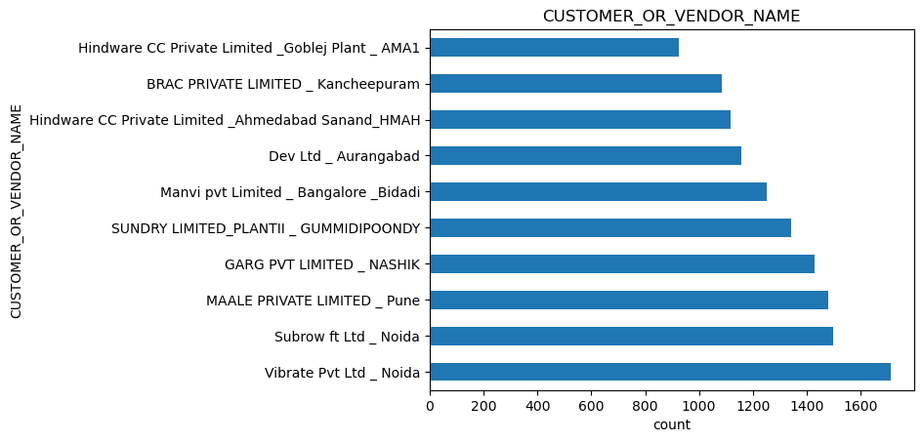

* 2875 unique customer are there
* These are the top 10 customers

**LOB column:**

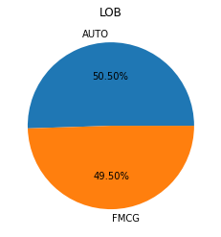

* Two unique LOBs are there AUTO and FMCG.
* AUTO 50.50% and FMCG 49.50%.

**Region column:**

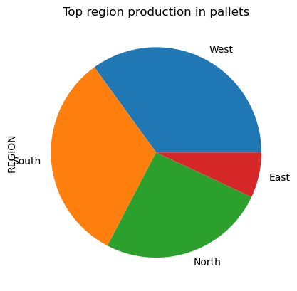

* Four regions
* West and south are mostly followed than North and East.

**BP TYPE column:**

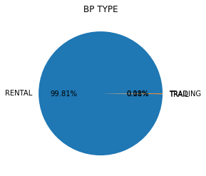

* Rental is the majority and trail done very rarely.

**City column:**

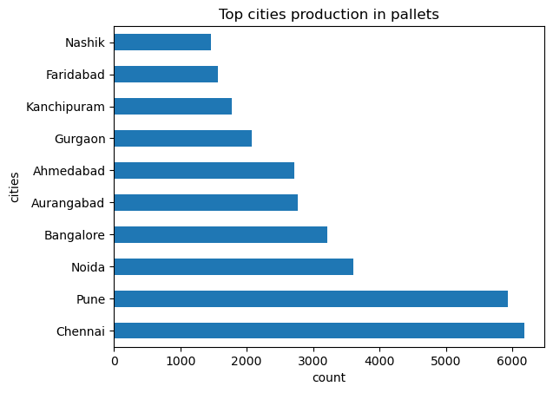

* 638 cities are there.
* These are the top 10 cities.

**State column:**

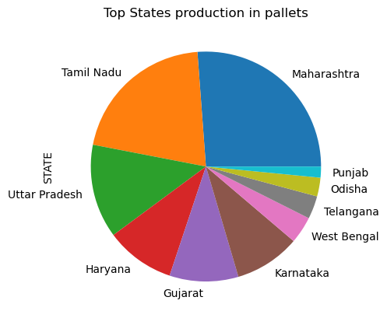

* 31 states are there
* Top 10 states are shown.

**from whs Name column:**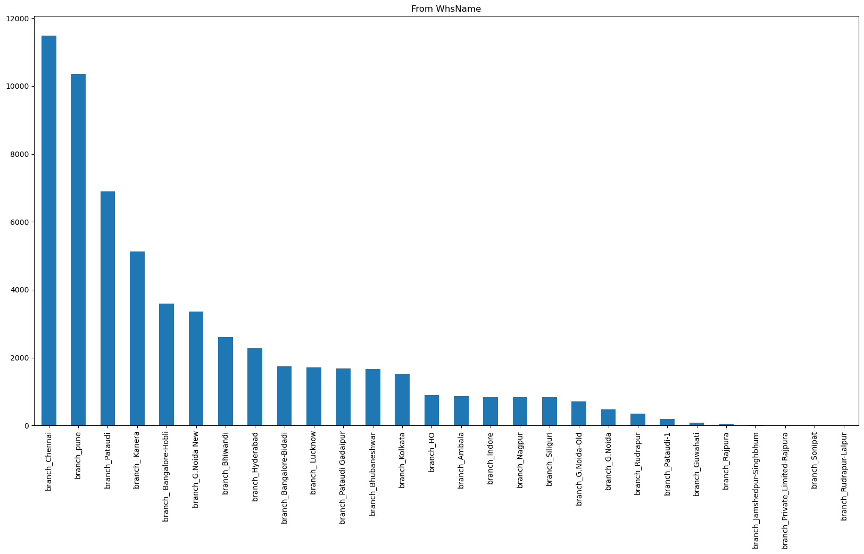

* 28 from warehouses are there.
* All the from warehouses are shown.

**from whs code column:**

* 41 unqiue from warehouses codes are there.

**To whs Name column:**

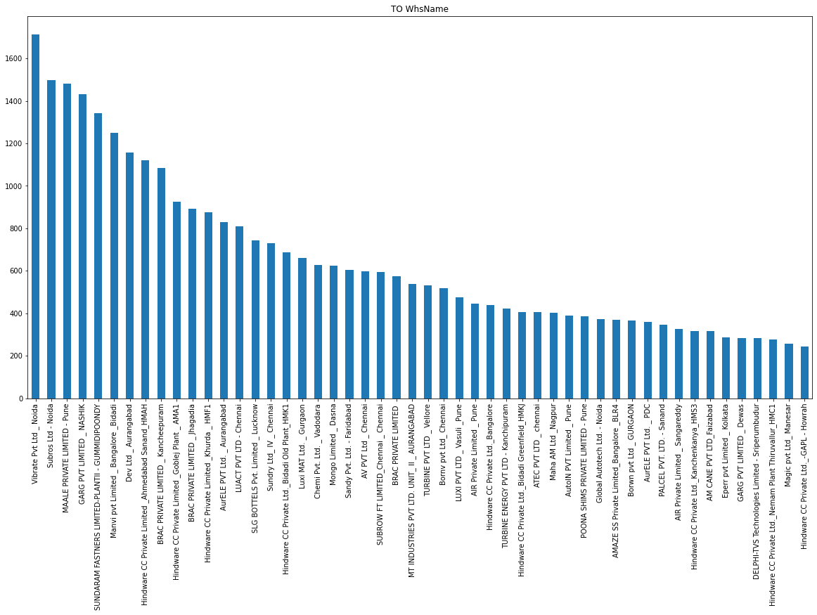

* 2871 To warehouses are there
* Top 50 To ware are shown.

**Model Type column:**

* Three model types Allot, damage swamp and trial.
* Allot is higher, damage swap is very less, trail is 0.005%.

**Transfer Type column:**

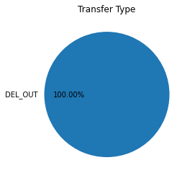

* Delivery out happened all the times.
* There is no such variation in transfer type.

**U_Frt column:**

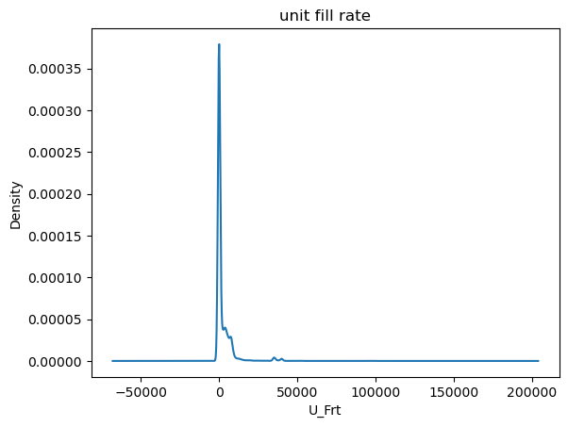Avg U_Frt: 2361.33.

* U_Frt consists of 19403 zeros and 735 nan values.

**U_ActShipType column:**

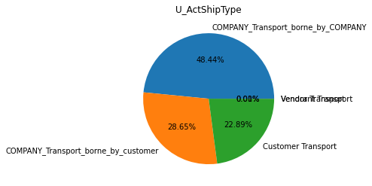

* There are 5 U_ActShipType.
* Company Transport borne by company is more followed by company transport borne by customer, customer transport.
* Other two are very few.

**Product category column:**

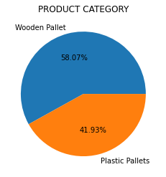

* There are 2 product categories wooden and plastic pallets.
* Wooden Pallets are more manufactured 58.07% and plastic pallets are 41.93%.

**Item Code column:**

* 42 unique items are present.

**NUMBER OF ORDERS PLACED column:**

* On an average 127 orders are placed by a customer.

**Description column:**

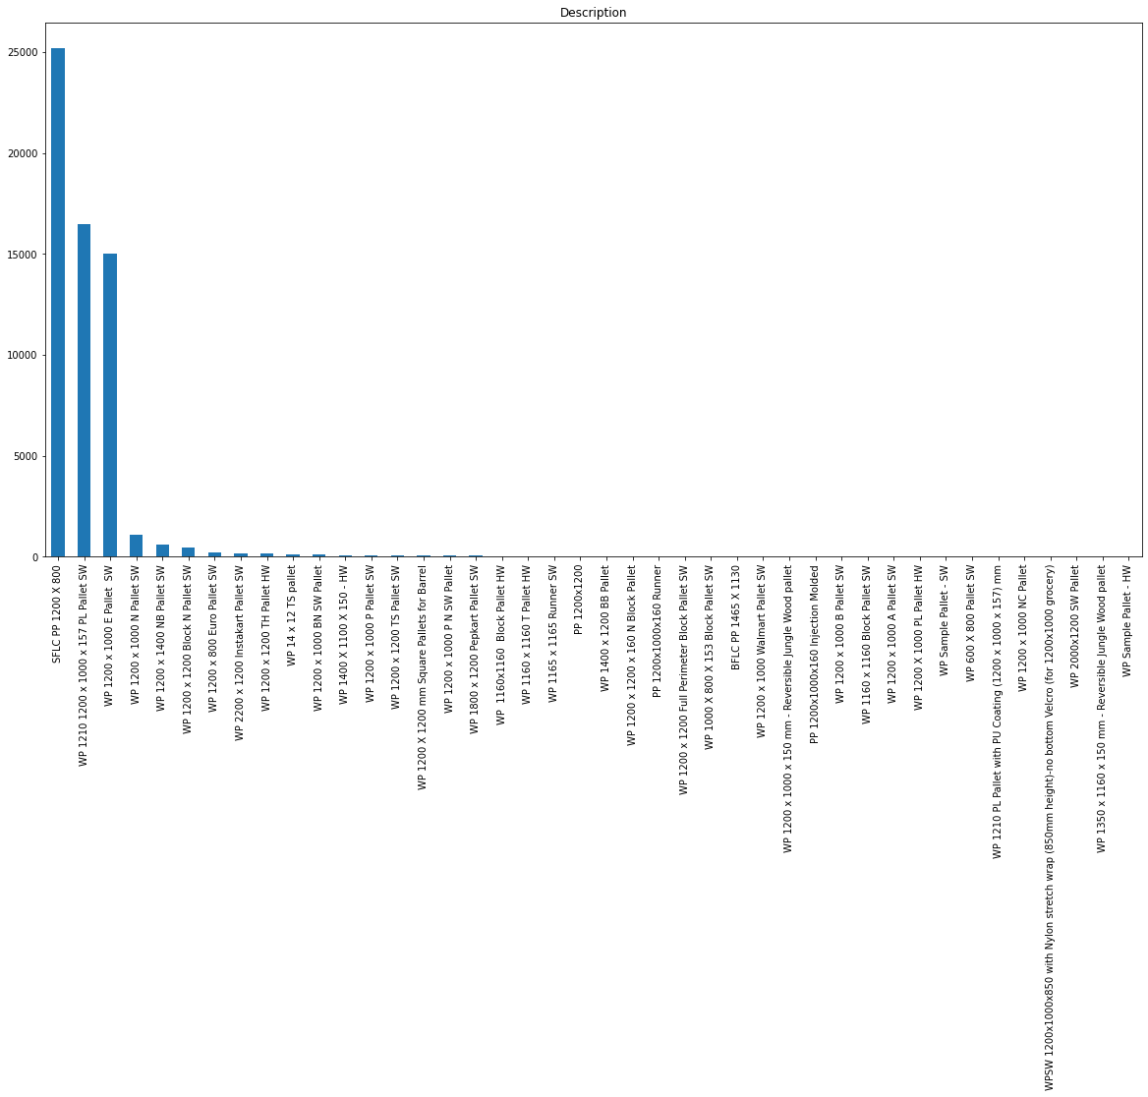

* There are 42 Descriptions of products.
* All Descriptions are shown.
* There size of pallets most oftenly manufactured.
* SFLC PP 1200 X 800 0.418923
* WP 1210 1200 x 1000 x 157 PL Pallet SW 0.274002
* WP 1200 x 1000 E Pallet SW 0.249672

**Quantity column:**

* Average Quantity received by the customer 109.

**Unit column:**

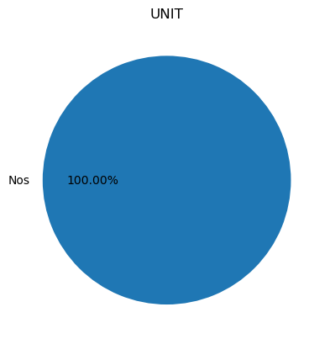

* Unit is given by nos. and it represents the number of quantities.

**Rate column:**

* Avg. rate is 2124.75.

**SO ID column:**

* 21383 unique sales Ids are there.

So creation Date and so due dates are two dates column of sales order creation date and sales order due date.

**U_Docstatus column:**

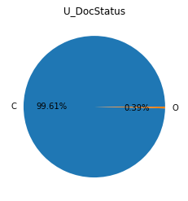

* C and O are two document status
* C happened most of the times and there is no such variation in this column.

**Document Type column:**

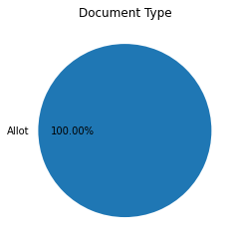

* Allot is the only document.

**Transporter Name:**

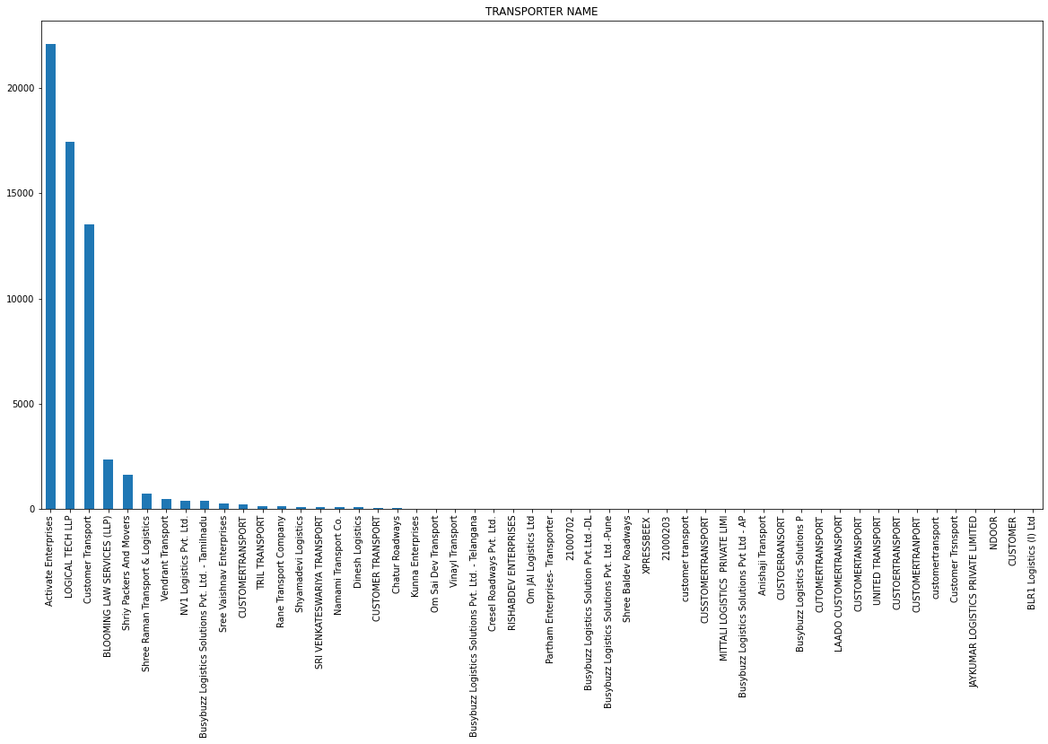

* 53 transporters are there

**Major transport**

* Activate Enterprises 0.367353
* LOGICAL TECH LLP 0.290156
* Customer Transport 0.224593

**BP_category column:**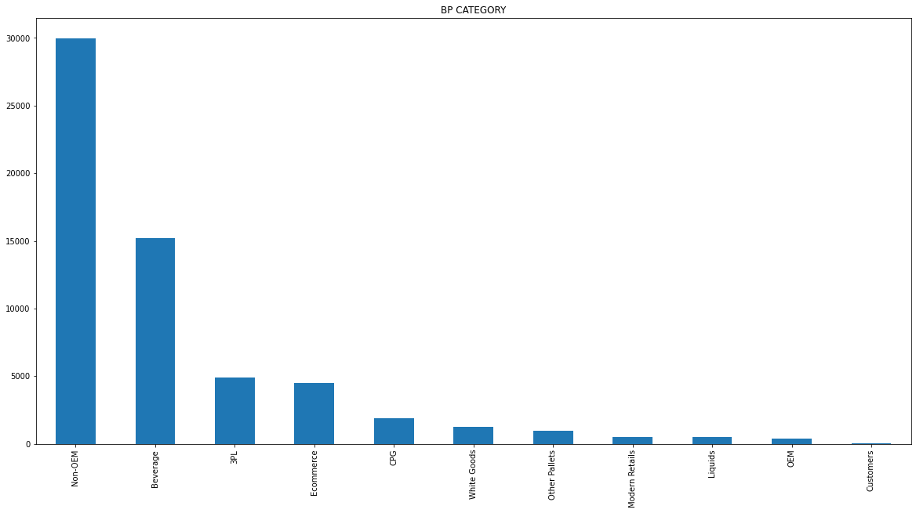

**Major Bp categories are**

* Non-OEM 0.498064
* Beverage 0.252414
* 3PL 0.081800
* Ecommerce 0.075152

**U_so type column:**

* Rent is the most happened and the rest is near zero.

**Vehicle Type column:**

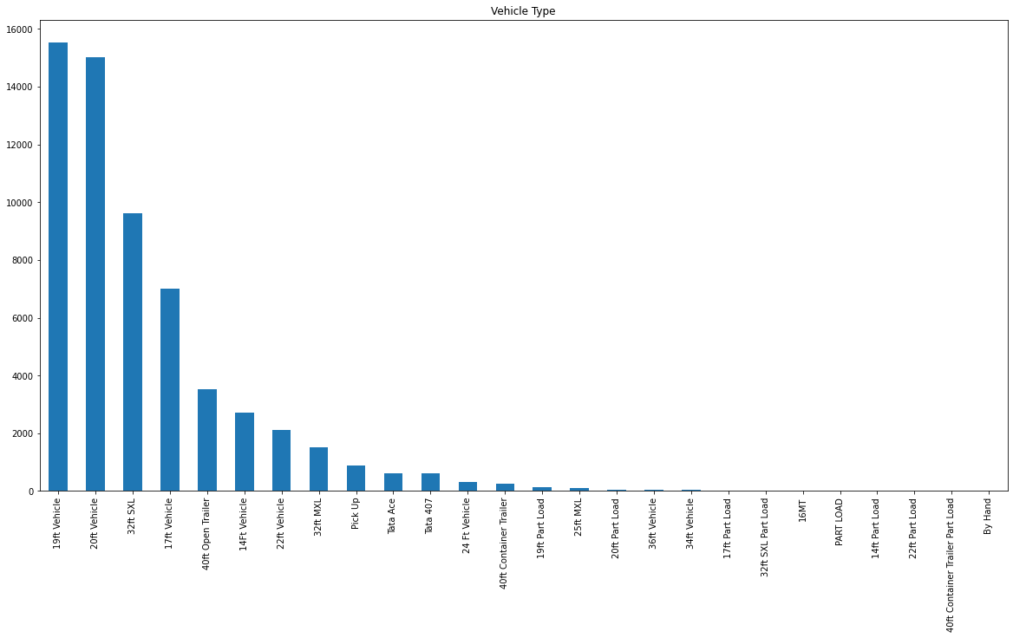

* 27 unique vehicles are there

**Major vehicles**

* 19ft Vehicle 0.258297
* 20ft Vehicle 0.249472
* 32ft SXL 0.159944
* 17ft Vehicle 0.116385
* 40ft Open Trailer 0.058433

**Direct dispatch column:**

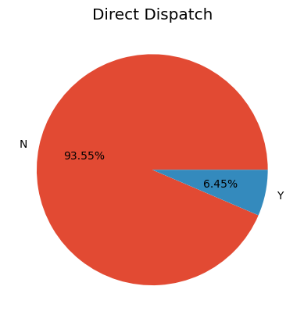

* N happened most of the time.
* Y happened to be the least.

**Loading/unloading column:**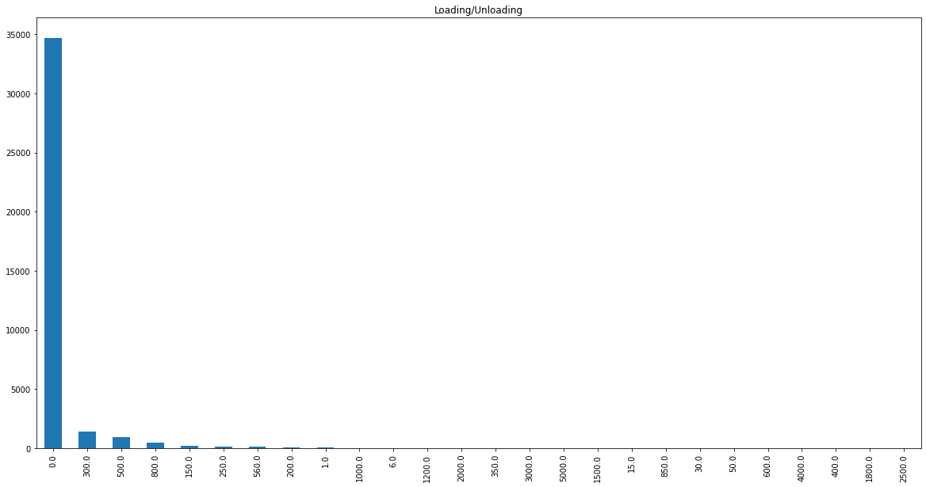

* loading/unloading doesn't happen most of the times.

**Business head column:**

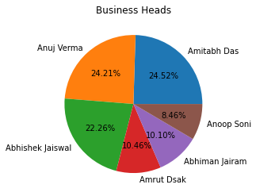

* Total 6 business heads.
* Amitabh das and Anuj Verma, Abhishek Jaiswal are the top most business head, followed by amrut Dsak, Abhiman Jairam and Anoop Soni.

**Kititem column:**

Unique id of each kit item.

**Num_cart type column:**

Nan values present in the column.

**U_GRNNO. column:**

* Goods receipt note entries.

**U_TRINPD column:**

* This column consists of nan values.

**P.O. reference column:**

* This column consists of nan values.

**Unnamed: 46 column:**

* Unable to describe.

**Customer Type column:**

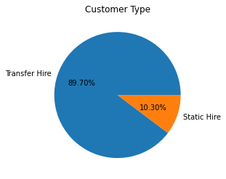

* Two types of customers.
* Transfer hire is the majority followed by static hire

DASHBORD INSIGHTS

